Assignment 2

# By Lin Ngo

## ID: 113477633

### Repo Link: <https://github.com/KimShiBall/SWE-Assignment-1>

### Task 1:

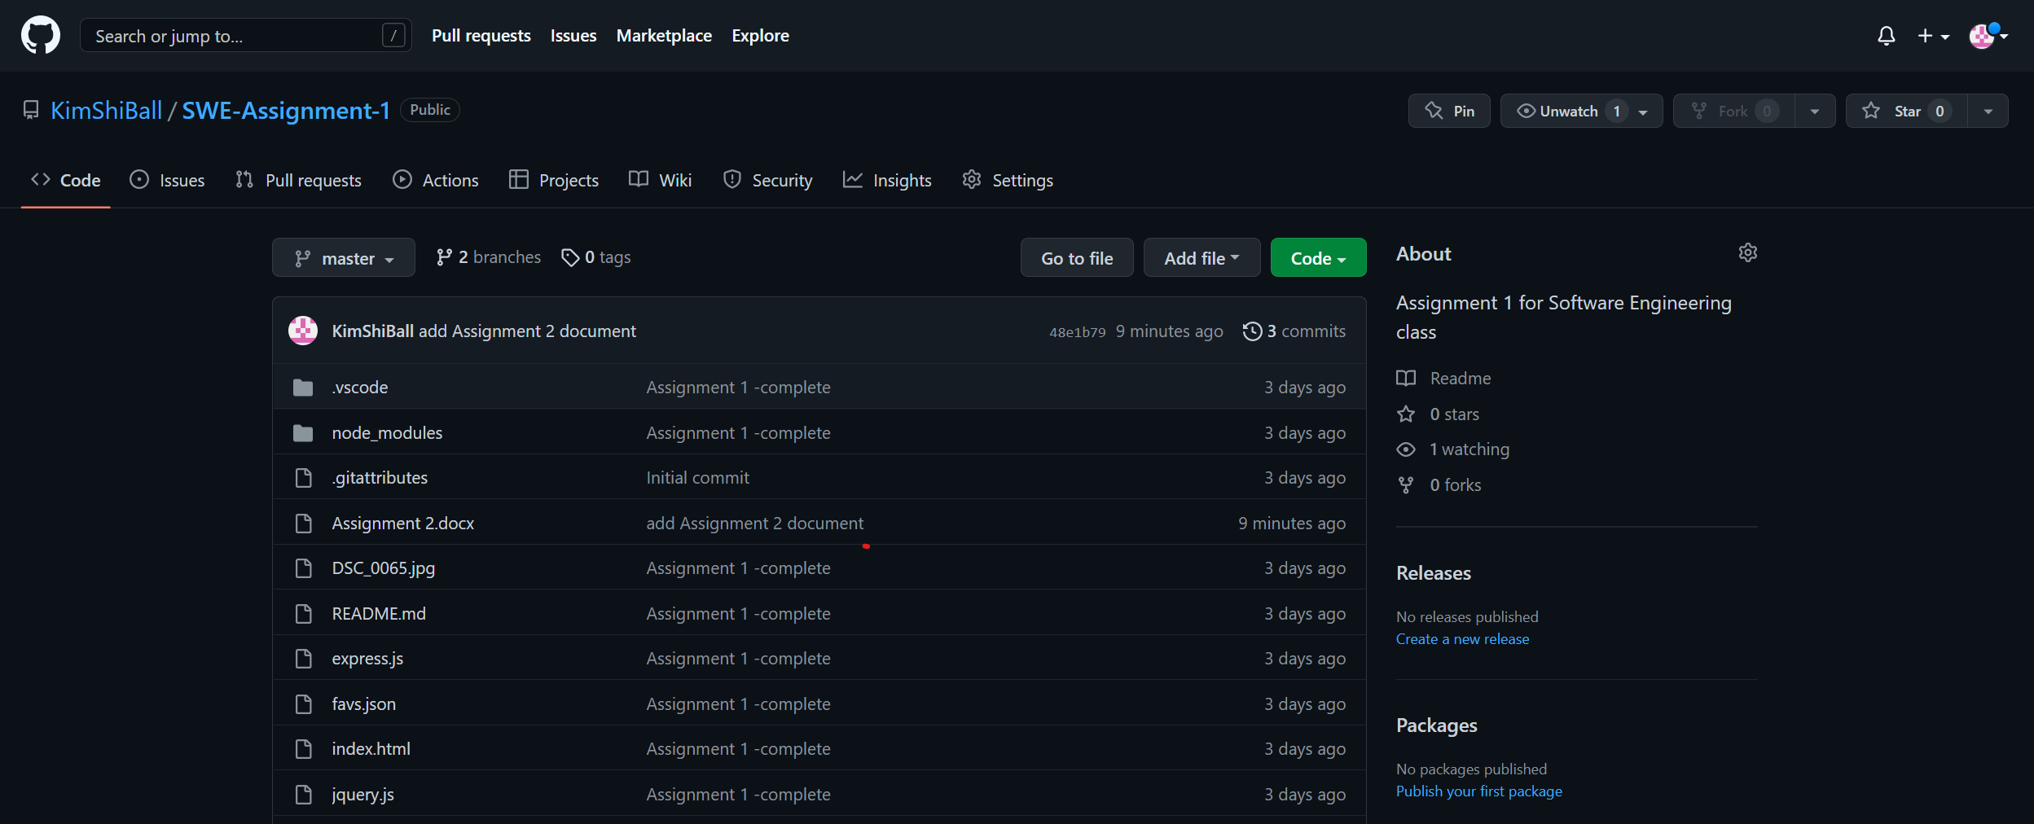

### Task 2:

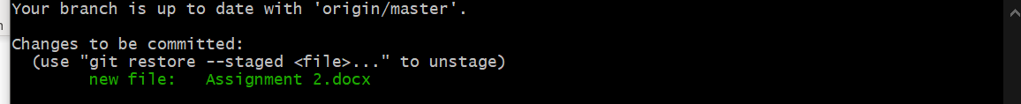

### Task 3:

### Task 4:

### Task 5:

### Task 6:

### Task 7:

### Task 8:

### Task 9:

### Task 10:

